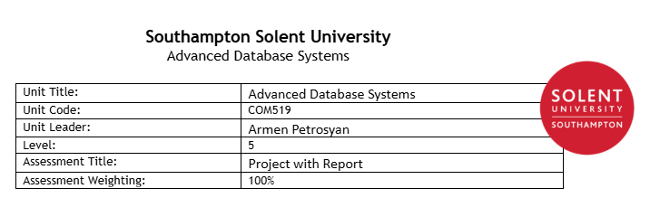

Introduction 1
Bibliography 2
Appendix A - Creation of DB 2
Appendix A - Initialisation of DB data 2

Introduction

This project is to create a hub application for local garages to combine services to service their customer bases. Currently each garage has its own setup for customer interactions as well as payment and related services, which can create many different routes for customers and fluctuating experiences.

The aim of the project is to allow a single sign on service for customers to select garages & services, streamlining the interactions to the garages and reducing the requirement for localized interfaces; websites for example for the first year can cost estimated £5,375 with £875 ongoing when design, domain name(s), security and hosting is included Stevens, W. (2025). With a Single-platform application within this project can be £5,000-£12,000 depending on scale McGuire, J. and McGuire, J. (2025), however this would be a single cost that can have many sites/customer within, saving overall costs.

The applications will cover these core requirements:
- Login system for customer & staff, to interact with services
- Account management including vehicle history shared across garages
- Garage accounting enabling the addition of special offers, reductions and passing customer to other locals when services cannot be provided (encouraging specialisation and sharing/increasing existing customer bases)
- Streamline billing services, including itemised receipting
- Stock management for garage supplies
- Easy onboarding for new garages & customers
- Reporting suite for frequently ordered stock, customer trends & financial returns

Bibliography

- Bridges, J. (2025) How to write a business case (Example & template included). https://www.projectmanager.com/blog/how-to-write-a-business-case
- Stevens, W. (2025) How much does a UK website cost? (Full guide updated). https://www.godaddy.com/resources/uk/smallbusiness/how-much-does-it-cost-to-build-a-website-uk
- McGuire, J. and McGuire, J. (2025) How Much Does it Cost to Develop an App in the UK (Everything You Need to Know). https://www.pulsion.co.uk/blog/how-much-does-it-cost-to-develop-an-app-in-the-uk/

Appendix A - Creation of DB

Attached sql scripts to create all database tables:

TODO: link notepad++ file

Examples of relational constraints: bookings table

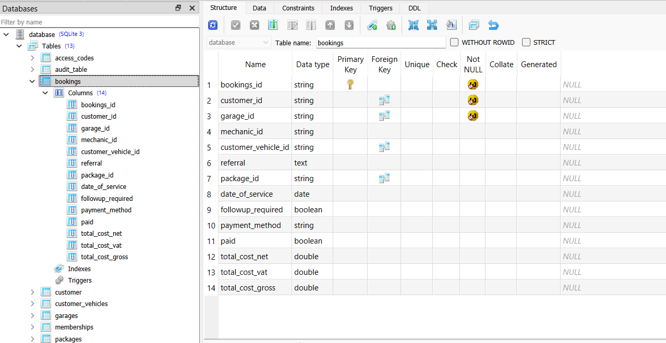

References id(s) from garage, customer, vehicle and packages, ensuring that bookings table is at its core transactional reference data that can be used as jumppoint for reports & query searches into the database

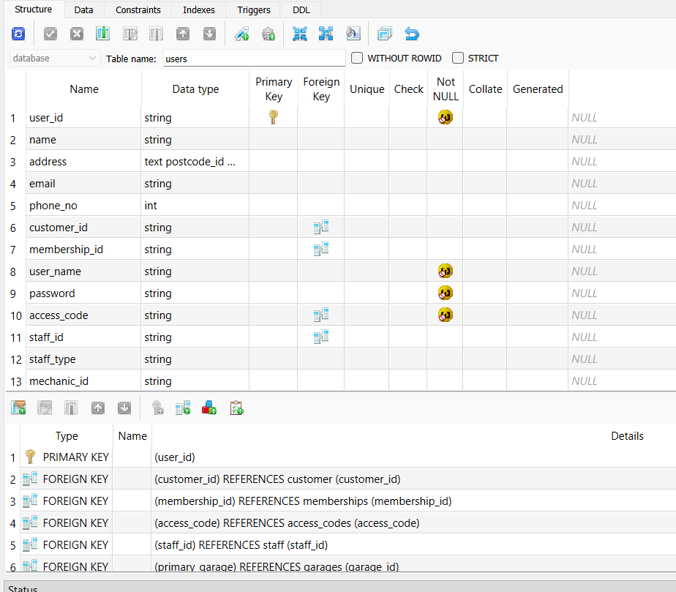

Users table in the same fashion, references many other tables and pulls data to ensure that relational data is held. For example access_codes input have to exist within that table, otherwise validation checks on access cannot be completed reliably from the user table alone; meaning any access checks would require check of user data AND access code table data.

Appendix A - Initialisation of DB data
Attached sql scripts to create database data within tables:

TODO: link notepad++ file

Example of created data from insert:

Example of constraint data being enforced with the inserting into the database. Customer data hasn’t been inserted yet, and customer_vechicale has been attempted to be created:

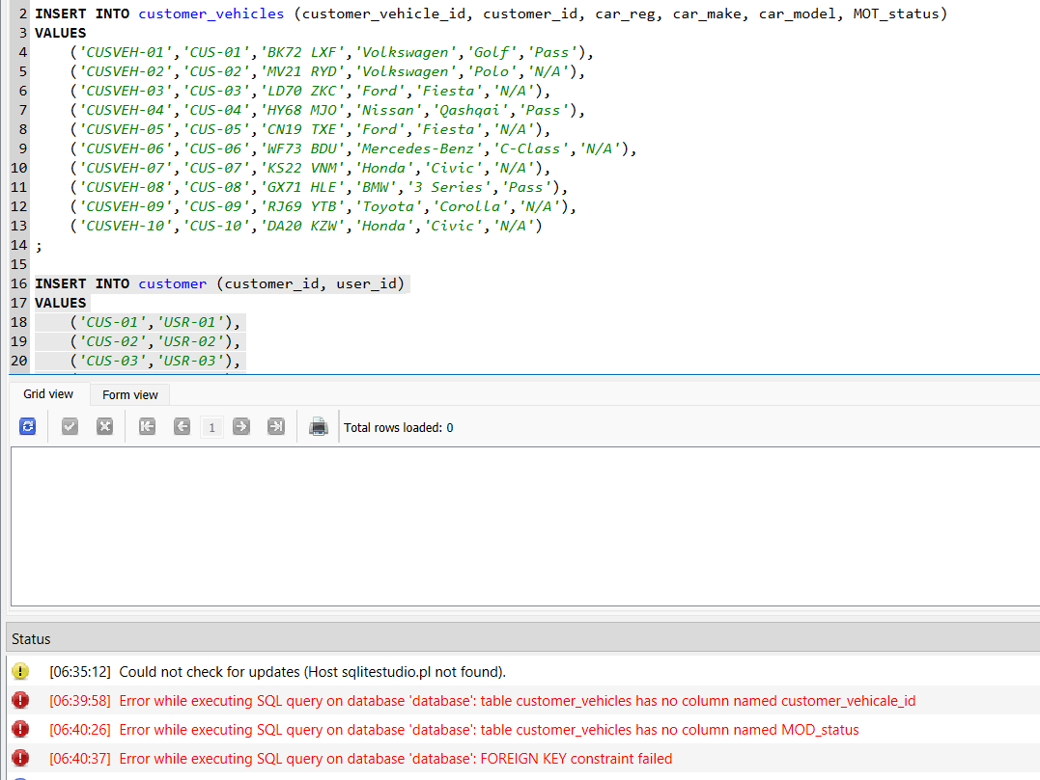

The data from the 3NF, has links to the customer table:

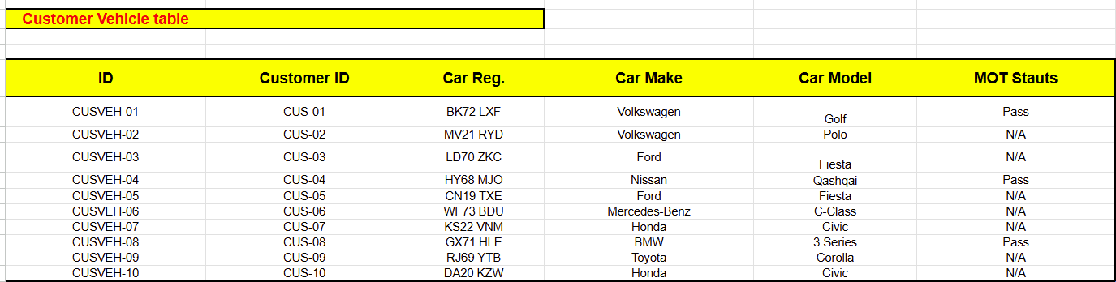

Mirrored with the database setup with forgien keys:

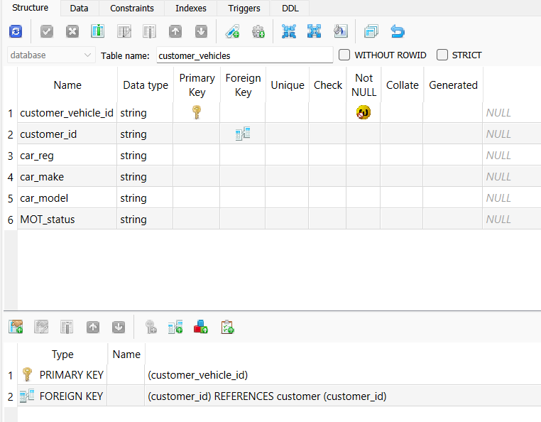

CREATE TABLE customer_vehicles (
customer_vehicle_id string NOT NULL,
customer_id string,
car_reg string,
car_make string,
car_model string,
MOT_status string,
PRIMARY KEY (customer_vehicle_id),
FOREIGN KEY (customer_id) REFERENCES customer(customer_id)
);

